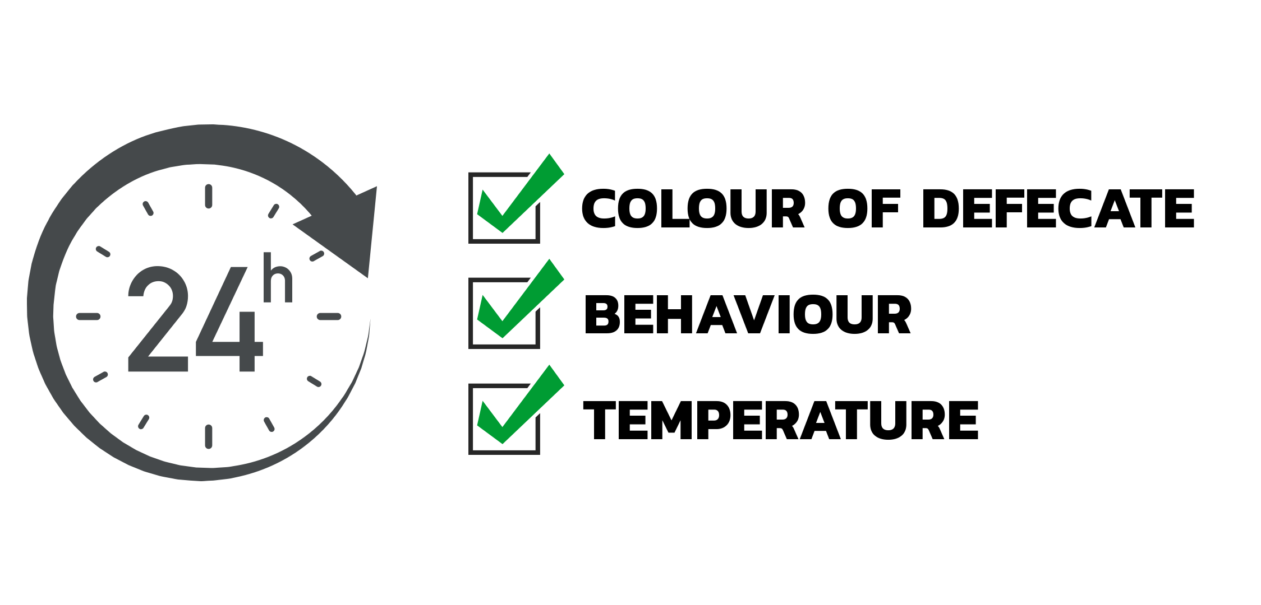**Introduction**

Have you ever been unsure of your pet’s health? Do you know if they're in pain? Fancy a video call with your favourite furry friend? Well, we have the solution.

PPET allows owners of the device to monitor their pets remotely from anywhere, anytime. Whether you are an owner of a pet, owner of the pet shop or a pet breeder, monitoring of the pet’s health and constantly checking if there is a need to clean the defecate is a manual and tedious task.

With PPET, all these are being monitored and you can simply review the records from your mobile application. Valuable data on the pet’s health (Temperature, defecate abnormalities) are recorded and analysis of such data is being performed to allow early detection of illnesses in pets.

**Target Audience**

* Pet Owners
* Pet Shop
* Pet Breeders

With the rise in Singapore’s overall pet ownership, pet dogs and cats’ figures have grown nearly 19 per cent in five years to reach 196,600 in 2019, Euromonitor data show. (This figure includes pets not registered with AVS as well as adopted pets.)

Singapore's demand for furry companions is at an all-time high, stoking growth in the pet sector with uptrends in both local sales and imports of domestic animals. *Refer to Annex (Growing market for Pet Smart Devices)

**Product Features**

|  |  |
| --- | --- |
| **Features** | **Purpose** |
| Record and monitor pets’ health data | Body temperature of pet, images of defecate are recorded whenever they visit PPET device. Each pet will have their own records, which is made accessible via the web/mobile application. |
| Analysis of pets’ health data | Images of defecate are recorded and analysed to identify abnormalities based on the colour and hardness of defecate.  Data on their temperature (for fever) and frequency of visits will also be analysed to identify possible sickness syndromes and abnormalities. |
| Notification and review of abnormalities in health data | To notify owners of abnormalities in the pet’s captured data. It will also allow reviewing and analysis of each pet’s captured data.  E.g. High Temperature, Abnormal colour of defecate, abnormal defecate frequency. |
| Pet Forum | Where pet lovers gather to discuss their fur babies.  On these forums and sites, you can chat with other pet owners and experts for advice, information, share experiences and opinions, or ask questions.  'Missing' and 'Blood donation' sections aid pet owners searching for their missing dog and owners looking for a suitable donor. |
| Monitor your pet & soothe separation anxiety | An interactive camera and audio allows the owner to monitor and interact with the pet from the web/mobile application.  This allows owners to communicate with their pets, which can sometimes help to soothe separation anxiety that may result in persistent barking, thereby disturbing neighbours. |

**Product Pricing**

|  |  |  |
| --- | --- | --- |
|  | **Basic** | **Premium** |
| PIR motion sensor | **✔** | **✔** |
| Temperature sensor | **✔** | **✔** |
| Camera Module | **✔** | **✔** |
| Interactive audio-video camera | **-** | **✔** |
| Setup Cost per unit | $ 250 | $ 450 |
| Monthly subscription per unit* | $ 3.90 | $ 8.90 |

**\***For data storage, report and analysis capabilities. 15% discount off subscription for 10 units and above

**How PPET Works**

1. When a pet arrives at the pet tray and PPET device sensor detects motion, the temperature sensor would be activated to capture the pet's body temperature.
2. Upon leaving the pet tray, the camera module will capture an image of defecate left behind. No record will be created if the image is analysed and deemed to not be the pets defecate. (E.g. Toys)
3. Analysis on the stool texture and stool colour would be performed on the image.
4. All data and analysis would be recorded for access via the web/mobile application.

*Refer to Annex (PPET Model Setup)

**How our product plays a crucial role**

In February 2020, we participated in a competition called “Ideator Singapore” hosted by Singapore Power Group. This competition focuses on incubating ideas to bring Singapore towards the Smart Nation goal, where we were awarded 3rd place and received their support in bringing our project forward into commercialisation. We are touching base with Pet Lover Center for a trial on the setup.

Pet tech is a natural extension of the growing IoT ecosystem, where physical devices and sensors are Internet-enabled to allow access and control by the users remotely.

Pet’s health is a crucial factor driving the market and what pet owners seek when it comes to products that can help them. Tracking activity and behavioural data on pets can help identify possible health conditions based on their usual sleeping pattern, eating habits, respiratory rhythm, and other data.

PPET will be the future nurse, doctor to help you monitor and provide advices on your best friend’s health, giving you the peace of mind, that at the end of a long day, your four-legged family member will be there to greet you at the door, with a healthy body and wagging tail.

Additionally, PPET will also create more opportunities to build a stronger bond within the community by providing a platform for pet’s owners to come together and discuss pet health related topics and more.

**ANNEX**

**Growing market for Pet Smart Devices**

<https://www.straitstimes.com/tech/growing-market-for-smart-pet-toys-and-gadgets>

With the rise in Singapore’s overall pet ownership, pet dogs and cats figures have grown nearly 19 per cent in five years to reach 196,600 in 2019, Euromonitor data show. (This figure includes pets not registered with AVS as well as adopted pets.)

While sales data for smart pet devices in Singapore is unavailable, the global market for such products was estimated to be worth US$1 billion (S$1.4 billion) at the end of last year, according to US-based market intelligence firm Transparency Market Research.

**Survey on average spending on pets**

<https://www.opploans.com/blog/how-much-does-your-state-spend-on-pets-we-have-the-answer-and-more-for-national-pet-day/>

According to a recent survey,

|  |  |
| --- | --- |
| pet owners | spend a monthly average of $126.19 on their furry friends, and this does not allow them to have a capability of monitoring the health of their pets |
| shop owners and breeders | cost is even more as they have many pets that need to be monitored, which are done manually by their staff. |

**How PPET Works**

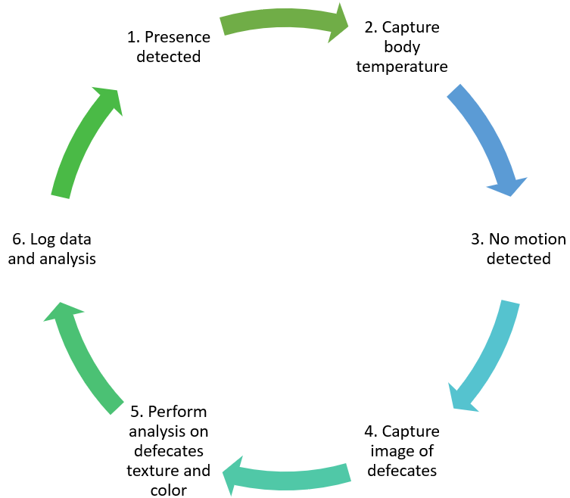

**PPET Model Setup**

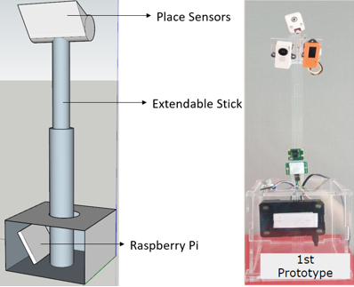

**Body Temperature of Dogs**

<https://vcahospitals.com/know-your-pet/taking-your-pets-temperature>

|  |  |
| --- | --- |
| Normal | 38.33 to 39.17 degree Celsius |
| Fever | 39.44 degree Celsius |
| Serious | 41.11 degree Celsius |

**Defecate Indications by Colour**

<https://petadvice.petdrugsonline.co.uk/dog-poo-colour-chart/>

**Defecate Indications by hardness**

<https://petadvice.petdrugsonline.co.uk/dog-poo-colour-chart/>